**Arangkada 2025 Investment Forum: Fueling the Philippines’ Next Economic Revolution**

**Manila, Philippines** – With an atmosphere charged with optimism, opportunity, and visionary thinking, the Arangkada 2025 Forum, organized by the Joint Foreign Chambers (JFC) of the Philippines, concluded as one of the most impactful and transformative gatherings of the year.

Held for two dynamic days, the event brought together a roster of high-level participants, ranging from influential business leaders and top policymakers to global leaders and thought leaders, including Global Tax Policy Expert and renowned tax advocate Mon Abrea, where he shared insightful industry talk focused on critical areas, including tax policy reform and proposals, tax incentives, and the CREATE More Act.

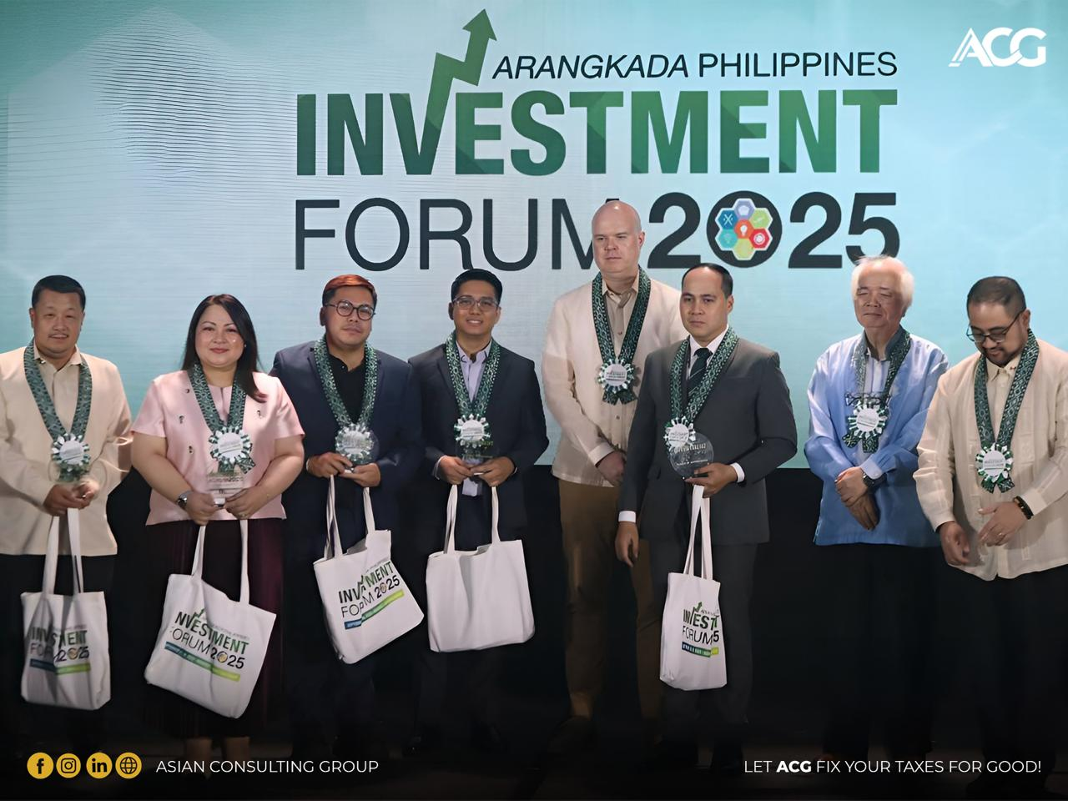

He also shared his expertise on the Ease of Doing Business in the Philippines, offering a deep dive into the country’s evolving tax system. During his presentation, he introduced highlights from his book, *"Why* *Invest in the Philippines: A Guide to Investing and Doing Business in the Philippines –* *CREATE More Edition*," which highlights key tax incentive policies and the government's ongoing efforts to streamline business processes.

In its 14th year, Arangkada has cemented its status as the premier economic forum in the country, as an essential platform where vision meets action and policy converges with progress.

The 2025 Arangkada Investment Forum elevated the dialogue to new heights, featuring a rich lineup of plenary sessions, sectoral breakout discussions, and powerful business-to-business (B2B) and business-to-government (B2G) networking engagements that facilitated real-time collaboration and sparked high-impact partnerships.

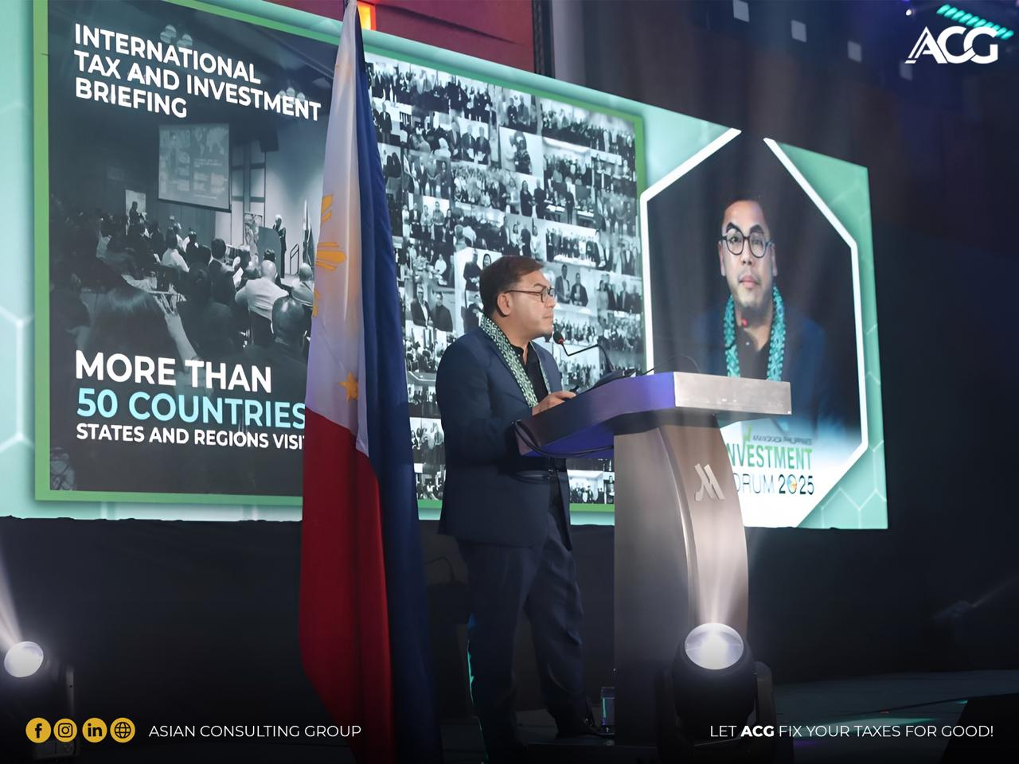

At the heart of this year’s forum was a renewed focus on the "Seven Big Winner Sectors" championed by the JFC: Infrastructure, Agribusiness, Tourism, Manufacturing and Logistics, Critical Minerals, Creative Industries, and Information Technology and Business Process Management (IT-BPM).

These sectors are poised to serve as key engines of growth, and the Forum provided a platform for deep dives into the policies, innovations, and investment strategies that will unlock their full potential.

Participants walked away with more than just insights; they left with concrete strategies, meaningful connections, and a renewed confidence in the Philippines’ long-term economic trajectory. From groundbreaking infrastructure plans to rising opportunities in green energy and digital innovation, the Forum was a showcase of ambition, resilience, and the nation’s readiness to take bold strides toward sustainable development.

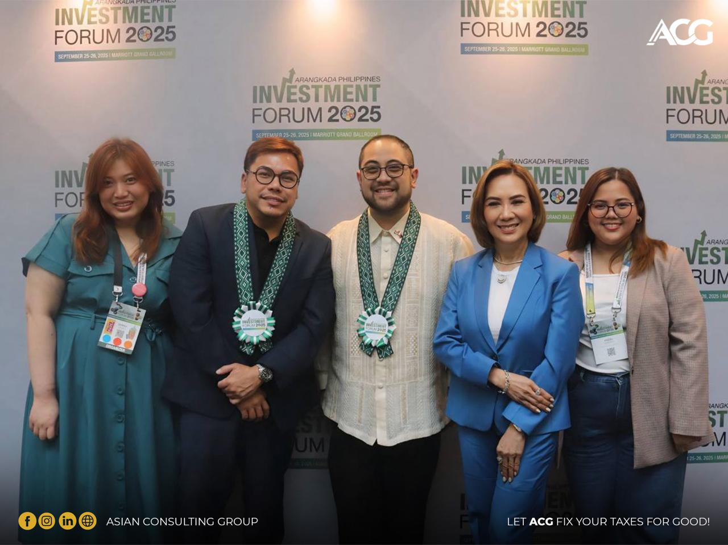

**About ACG:**

ACG is the most trusted tax advisory firm in the Philippines, providing tax strategy, compliance, and policy advisory services to multinational corporations, foreign investors, and government institutions. With a strong presence in Asia and an expanding global network, ACG continues to bridge the gap between international investors and the dynamic Philippine market.

**To explore partnership opportunities or join ACG’s global investment promotion initiatives,** [**CONSULT ACG**](https://acg.ph/)**, or you may also send an email to consult@acg.ph.**